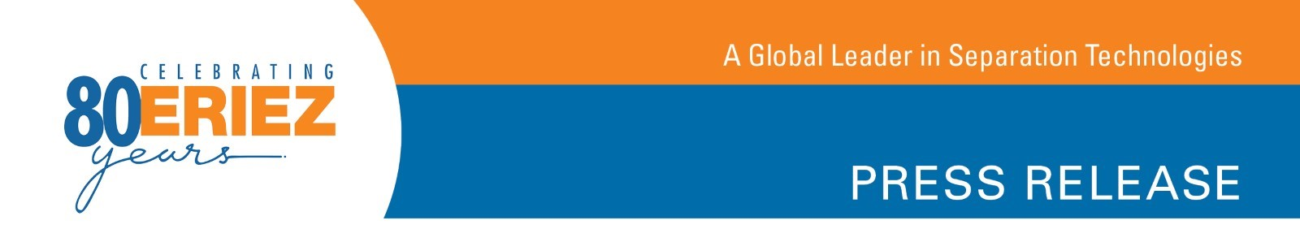
News for the Recycling Industry

Recently Updated Eriez® RevX-E® Eccentric Eddy Current Separators Offer High Performance with Minimal Maintenance

Erie, PA—The RevX-E®, the newest eccentric eddy current separator from Eriez®, gives customers the same high quality performance as previous units in a more maintenance-friendly package.

Eriez Separation and Recycling Product Manager Chris Ramsdell says the company consulted with recycling customers and designed the RevX-E to meet their needs. He explains, “We consistently heard the same demands from customers: they wanted high power with low maintenance, minimal downtime and a longer service life. We delivered on all these points with our RevX-E Eddy Current Separator.”

Eriez’ RevX-E Eddy Current Separators feature an eccentrically mounted magnetic rotor within a non-conductive shell for separation of nonferrous metals. The rare earth rotor produces a powerful field focused at the end of the belt.

“We thought a lot about ease of maintenance when developing this machine,” says Ramsdell. The RevX-E’s updated design takes up less floor space and incorporates a cantilevered frame which enables maintenance staff to change the belt in less than 10 minutes. A new hood with adjustable splitter allows operators to handle nonferrous materials in varying sizes and ensures optimum separation. Large access panels all around the machine make entry for maintenance hassle-free. Units also include direct drive for both the rotor and conveyor.

The RevX-E is available in two models: ST22 and LT2. Both models are manufactured on the same eddy current separator framework. Ramsdell says the only difference between the ST22 and LT2 is the magnet configuration on the rotor assemblies.

ST22 features a 22 pole rare earth eccentric rotor and is designed to handle fine materials that are less than 1-inch. This rotor option offers a high pole change frequency for removal of fine nonferrous metals from shredded plastics / PET flake.

LT2 features an eight pole rare earth eccentric rotor and is designed to handle 1-inch and larger coarse materials. This rotor option offers a deep, high-powered eddy current field that allows for the removal of larger nonferrous metals such as crushed aluminum cans from a PET bottle stream.

To learn more about the Eriez RevX-E Eddy Current Separator, visit http://erieznews.com/nr516. From this webpage, visitors can watch a video tutorial on the RevX-E 10-minute belt change and access an array of product literature.

-More-

Established in 1942, Eriez is a global leader in separation technologies. Our commitment to innovation has positioned us as a driving market force in several key technology areas, including magnetic separation, flotation, metal detection and material handling equipment. The company’s 900+ employees are dedicated to providing trusted technical solutions to the mining, food, recycling, packaging, aggregate and other processing industries. Headquartered in Erie, Pennsylvania, USA, Eriez designs, manufactures, and markets on six continents through 12 wholly owned international subsidiaries and an extensive sales representative network. For more information, visit www.eriez.com.

###

