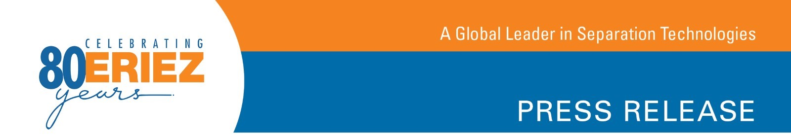

News for the Recycling Industry

Impressive Separation Results and Sampling Tests are Driving Demand for Eriez®
Ultra-High Frequency Eddy Current Separators

Erie, PA—According to Eriez®, an escalating demand for the company’s innovative Ultra-High Frequency (UHF) Eddy Current Separators correlates with an increasing number of prospective customers who are taking advantage of Eriez’ sample testing capabilities. Material testing and existing installations are proving the Eriez UHF Eddy Current Separator typically recovers an additional three percent of previously unrecovered zorba which would be otherwise missed by existing upstream equipment.

Introduced in 2016, the Eriez UHF Eddy Current Separator generates significant new revenue for scrap metal processors by recovering valuable aluminum, copper and other nonferrous fines as small as 2-3 mm from automobile shredder residue (ASR), without the requirement for expensive sensor based or optical sorting equipment.

Leading-edge scrap metal processors, including Illinois-based Scrap Metal Services (SMS) and Ohio-based Garden Street Iron & Metal, utilize Eriez UHF Eddy Current Separators to recover thousands of additional tons of premium zorba annually. These units feature a state-of-the-art rotor and revolutionary design which creates high frequency changes. This results in a recovery rate that is impossible to match with traditional eddy current technology.

Recycling Product Manager Chris Ramsdell explains, “When it comes to upgrading and improving metals recovery, challenges vary from application to application. That is why we encourage processors to send their material samples to us for testing in our Central Test Lab.” He says, “Recovery results using a customer’s own sample effectively demonstrates the potential profit that customer can gain by implementing Eriez solutions.” He adds, "When dealing with the fines waste fraction, the UHF Eddy Current Separator often proves to be the ideal equipment choice.”

According to Eriez, the typical input to the UHF Eddy Current Separator is the fines waste fraction from a customer’s existing nonferrous processing line. The product off the UHF Eddy Current Separator is a high-grade zorba package with considerably higher-than-normal copper content. Typically this fine zorba product is comprised of 20 percent or more red metals content, which can be sold at a premium.

Tests performed in the company’s Central Test Lab, located in Erie, Pennsylvania, often begin with around five to 10 gallons of material. Ramsdell says, “If the smaller scale tests look promising, we usually arrange a larger scale test at an existing installation to validate the recovery data.”

-More-

To find out how to send samples to the Central Test Lab, contact Eriez and ask to speak with a recycling product specialist. To see the Eriez UHF Eddy Current Separator in action, visit the company’s booth (#A5) at ISRI 2018. Additional Eriez recycling equipment will also be on display, including the RevX-E® Eddy Current Separator with Quick Change Belt System, Shred1™ Ballistic Separator, SMART System Monitoring and Report Technology and Brute Force Vibratory Feeders.

To learn more about the UHF Eddy Current Separator online, visit http://erieznews.com/nr449.

Established in 1942, Eriez is a global leader in separation technologies. Our commitment to innovation has positioned us as a driving market force in several key technology areas, including magnetic separation, flotation, metal detection and material handling equipment. The company’s 900+ employees are dedicated to providing trusted technical solutions to the mining, food, recycling, packaging, aggregate and other processing industries. Headquartered in Erie, Pennsylvania, USA, Eriez designs, manufactures, and markets on six continents through 12 wholly owned international subsidiaries and an extensive sales representative network. For more information, visit www.eriez.com.

###

