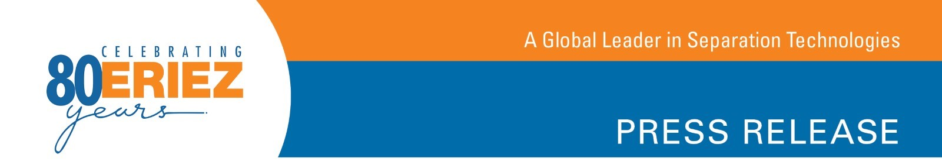News for the Recycling Industry

Field Results Confirm Eriez® UHF Eddy Current Separators Recover Nonferrous Fines Material Missed by Traditional ECS Units

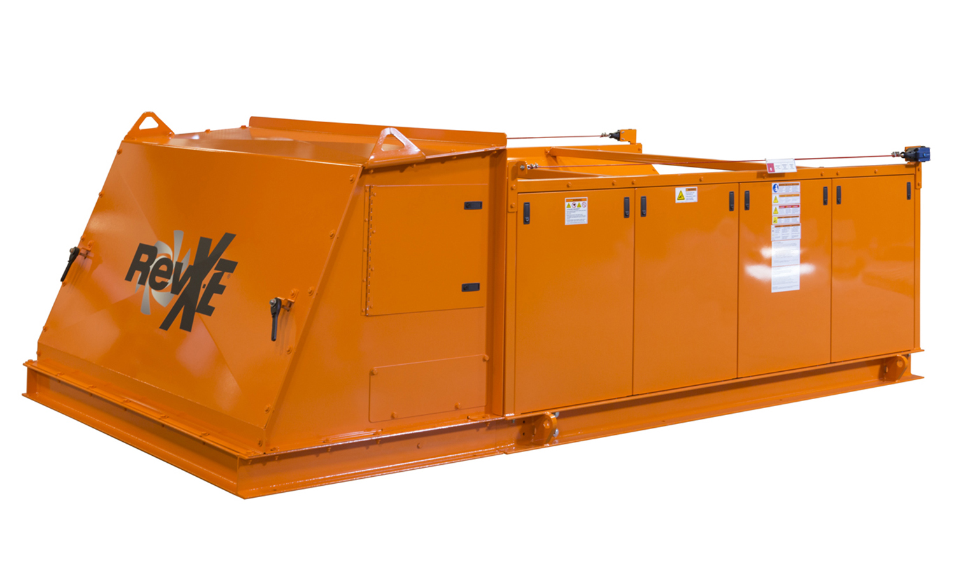
Erie, PA—Successful installations prove that Eriez® Ultra High-Frequency (UHF) Eddy Current Separators (ECS) successfully recover micro-fine aluminum, copper and other nonferrous fines from automobile shredder residue (ASR) that is missed by traditional machines. “Field results demonstrate this separator’s ability to reliably recover fine nonferrous metals, including bare copper wire, as small as 2-3 millimeters in size,” says Eriez Separation Product Manager Chris Ramsdell.

According to Eriez, the Ultra High-Frequency Eddy Current Separator’s innovative design is the key to superior performance. “A rotor designed to produce exceptionally high gauss on the belt surface, combined with the high-frequency changes of the permanent magnetic poles give this ECS the ability to consistently recover smaller nonferrous materials that were commonly missed by previous ECS designs,” says Ramsdell.

Eriez Ultra High-Frequency Eddy Current Separators offer an economic solution to improve Zorba recovery without the requirement for expensive sensor-based or optical sorting equipment. Each unit ships with an Eriez Brute Force Vibratory Feeder to ensure even presentation of material across the width of the machine to help maximize recovery.

Eriez patented the first eddy current separator more than five decades ago. Today the company offers a complete line of eddy current separators for a wide variety of industries and applications. To learn more about Eriez’ line of eddy current separators, visit erieznews.com/nr568.

Established in 1942, Eriez is a global leader in separation technologies. Our commitment to innovation has positioned us as a driving market force in several key technology areas, including magnetic separation, flotation, metal detection and material handling equipment. The company’s 900+ employees are dedicated to providing trusted technical solutions to the mining, food, recycling, packaging, aggregate and other processing industries. Headquartered in Erie, Pennsylvania, USA, Eriez designs, manufactures, and markets on six continents through 12 wholly owned international subsidiaries and an extensive sales representative network. For more information, visit www.eriez.com.
###

