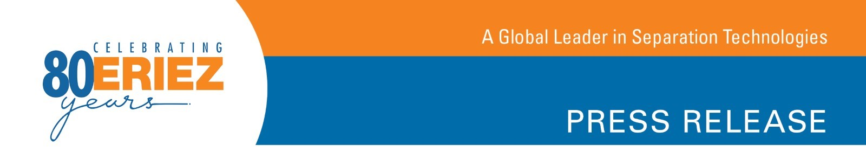

Customers Can Now Browse Available Refurbished Eriez® Processing Equipment Online

Erie, PA—Eriez® recently added a feature to its website which allows customers to view the refurbished equipment currently available. Every piece of Eriez refurbished equipment is repaired by the experts at the company’s 5-Star Service® Center, ready for quick shipping and backed by an “as new” warranty.

The Eriez Service Center, located in Erie, Pennsylvania, is equipped to remanufacture even the most complex systems. The fully staffed service center employs trained technicians and houses the machining, fabricating and welding capabilities necessary to rebuild all Eriez equipment.

Eriez says its refurbished equipment is guaranteed to operate at original equipment standards. “We stand behind our promise with our as-new warranty and make our team of professionals available 24/7, should an unexpected issue arise,” explains John Klinge, Eriez Director of Strategic Sales-Aftermarket.

The wide range of refurbished equipment typically available from Eriez includes eddy current separators, drum magnets, wet drum separators and suspended electromagnets. According to Eriez, the refurbished equipment web page is updated with newly refurbished equipment as it becomes available.
-More-
To learn more about the Eriez 5-Star Service Center and find out how the staff can fulfill practically any rebuild, repair and re-certification need, visit http://erieznews.com/nr525fivestar. To browse a current listing of available Eriez refurbished equipment, go to http://erieznews.com/nr525.

Established in 1942, Eriez is a global leader in separation technologies. Our commitment to innovation has positioned us as a driving market force in several key technology areas, including magnetic separation, flotation, metal detection and material handling equipment. The company’s 900+ employees are dedicated to providing trusted technical solutions to the mining, food, recycling, packaging, aggregate and other processing industries. Headquartered in Erie, Pennsylvania, USA, Eriez designs, manufactures, and markets on six continents through 12 wholly owned international subsidiaries and an extensive sales representative network. For more information, visit www.eriez.com.

###

